Name: <Your Name>

Github Username: <Your Github username>

Purdue Username: <Your PUID>

Instructor: <Ghasemi/Qiu/Kocaoglu/Makur>

**Problem1_writeup.**

**(1) Estimated Functions:**

(*Write numerical values for and )*

**(2) Data Visualization:** *(insert plot obtained from data in poly.txt)*

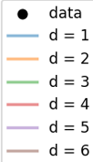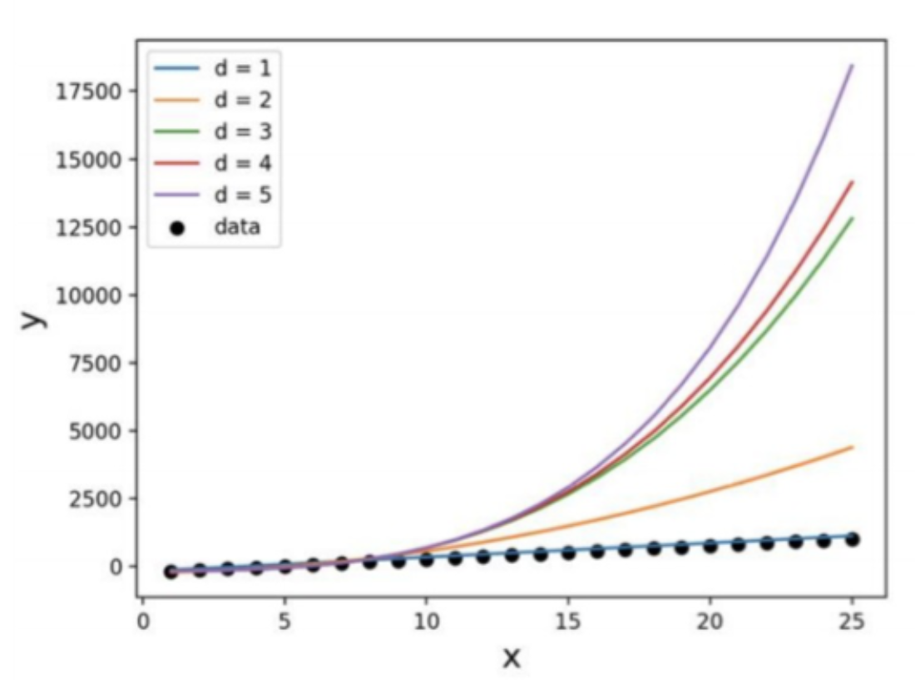

**(3) What degree polynomial does the relationship seem to follow? Please explain your answer.**

*(Discuss relationship of data and insert numerical value of c calculated from best regression)*

Sample answer:

The data seems to best follow a first order polynomial (i.e., a line) which can be seen from the   
low error between the estimated regression function, and the data in the plot above.

**(4) If we measured a new data point, what would be the predicted value of , based on the polynomial identified as the best fit in Question (3)?**

Sample answer:

If we measured a new data point, x=2, the corresponding predicted value would be = 𝑐.

**Problem2_writeup.**

**(1) Plot the mean squared error as a function of lambda in Ridge Regression:**

*(Insert plot obtained by completing the* ***main*** *function)*

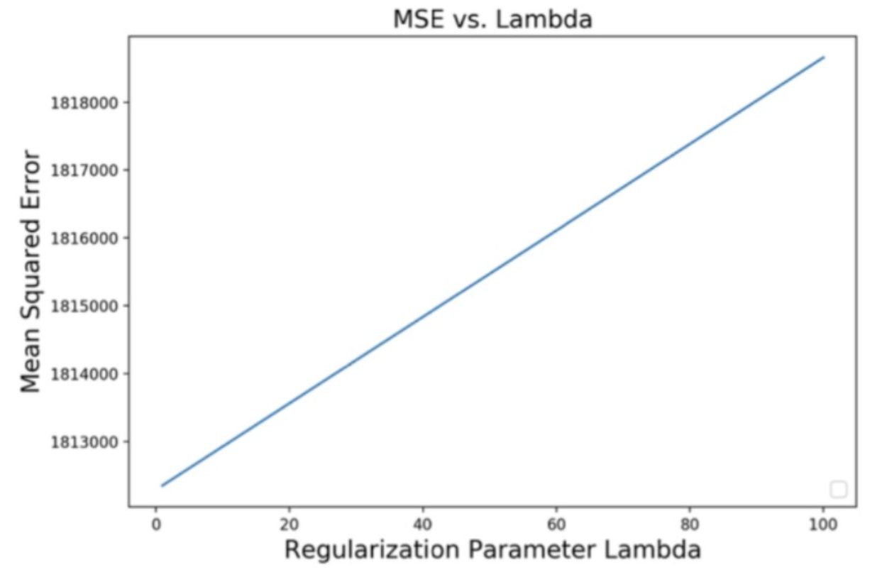

**(2) Find best lambda:**

Sample answer: *(insert numerical values for c and d)*

Based on the range of Lambda values tested, the best lambda value is , which yields an MSE of as shown on the plot above.

**(3) Find equation of the best fitted model:**

(*Insert numerical values for ’s and )*

**(4) Draw a prediction plot using Google data**

*(Note that the plot below is not the solution)*

